MetricConversion Mastery Assignment
Reflection Log
Stefan S
CSE 2110 Procedural Programming 1
(MetricConversion.java)
How has your program changed from planning to coding to now? Explain.
First working version of the program took 2 minutes to create. I copied some code from my Exponentiation skillbuilder to use as a template. I also realized at this point that I didn’t have to waste memory by declaring variables within my methods, I could just do the math directly and return the result.
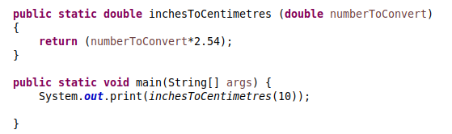
Directly afterwards, I also realized that I don’t need to return anything. If I wanted to format the output like the question wants me to, I’d either have to return a string or place the print statement into the method. I chose the latter. The updated program is as follows:
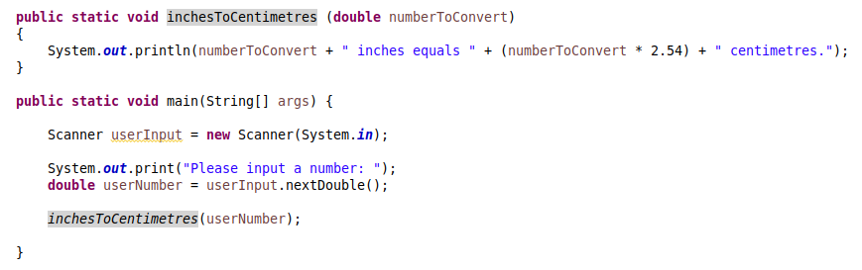

This is the final major version of the program, before I went along with the monotonous task of adding all the possible unit conversions.
